**Gillygooley Primary School**

**Mums & Tots**

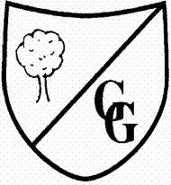

Come along with your little ones, enjoy a cuppa and meet new friends in our fantastic Primary School setting.

Everyone Welcome

Fridays 10.00 – 11.30am

During School Term (See Gillygooley P.S. Facebook Page)

Tea/Coffee/Juice/Snack

Cost £1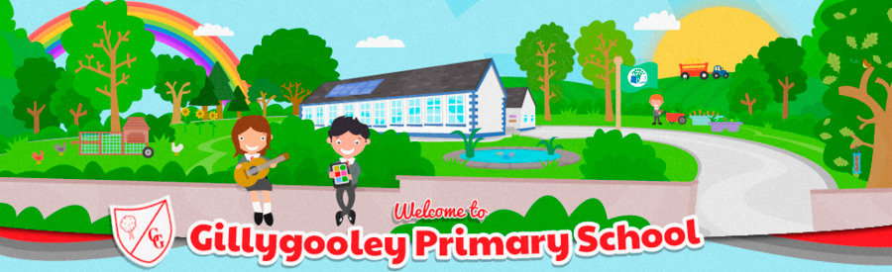

For more info/directions Tel: 028 8224 2932